SPORTING ACTIVITY

1. 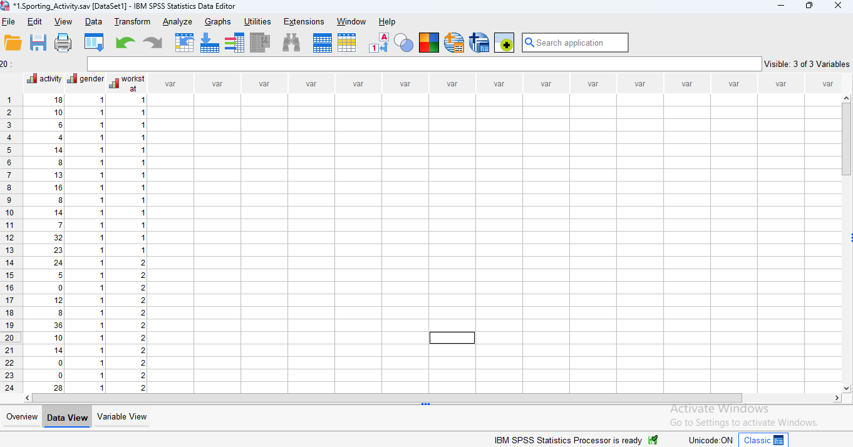

2.
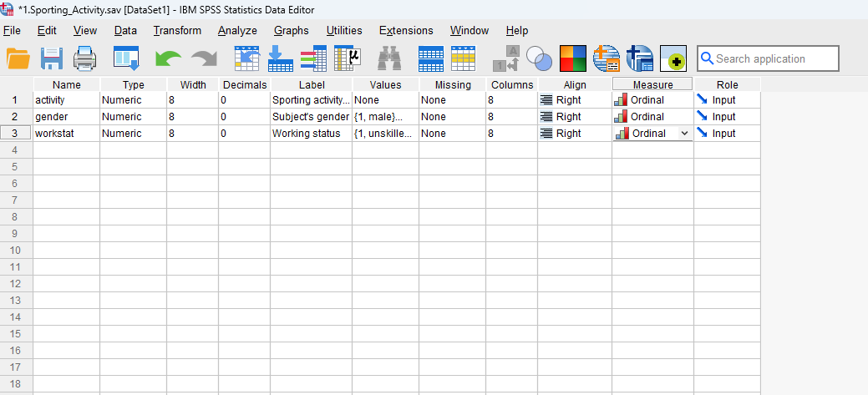

3. We want to compare group means, not relationships.
Correct test = Two-way between-subjects ANOVA.

4.
Tests of Normality :
By Shapiro-Wilk test, p Values have been achieved for
unskilled Male = 0.160
Skilled Male = 0.239
Unskilled Female = 0.039
Skilled Female = 0.379
3 out of 4 p values indicates normal distribution of data (p >0.05)
HOMOGENIETY :
Levene’s test showed that variances were significantly unequal across the four groups,
F (3, 48) = 5.09
p = .004.
However, due to the equal sample sizes in each group,
the two-way ANOVA is considered robust to this violation and was therefore conducted.

DIPENDEN VARIABLE: Hours are ratio data , suitable for parametric tests.

5. Two-way ANOVA is appropriate for this.

6. a)
F (1,48) = 3.898, P=0.054 – main effect for gender.
F (1,48) = 7.167, P=0.010 – main effect for work status.
F (1,48) = 5.178, P=0.027 – gender by work status interaction.

Tests of Between-Subjects Effects
Dependent Variable: Sporting activity count (hr/wk)
Source | Type III Sum of Squares | df | Mean Square | F | Sig. | Partial Eta Squared
Corrected Model | 1115.769ª | 3 | 371.923 | 5.414 | .003 | .253
Intercept | 6877.000 | 1 | 6877.000 | 100.113 | <.001 | .676
gender | 267.769 | 1 | 267.769 | 3.898 | .054 | .075
workstat | 492.308 | 1 | 492.308 | 7.167 | .010 | .130
gender * workstat | 355.692 | 1 | 355.692 | 5.178 | .027 | .097
Error | 3297.231 | 48 | 68.692
Total | 11290.000 | 52
Corrected Total | 4413.000 | 51
a. R Squared = .253 (Adjusted R Squared = .206)

b) The gender main effect is not significant, but both the work status main effect and the interaction are significant.
c) The main effect for gender shows that although the men reported that they were engaged in more sporting activity per month than the females (13.8 vs. 9.2 h·month⁻¹), the difference did not reach statistical significance. Nevertheless, the alpha value and the magnitude of the difference may be meaningful from a health and fitness perspective.
The main effect for work status shows that skilled people reported that they are engaged in more sporting activity than those who are unskilled (14.6 vs. 8.4 h·month⁻¹, respectively).
The interaction showed that whilst work status had little bearing on the sporting activity reported by males (13.3 and 14.2 h·month⁻¹ for unskilled and skilled respectively), unskilled females reported that they were engaged in far less sporting activity than their skilled counterparts (3.5 and 14.9 h·month⁻¹ for unskilled and skilled respectively).

(d) A non-significant main effect for gender (F_{(1,48)} = 3.90, P=0.054) revealed that the amount of monthly sporting activity reported by males and females was not different. However, closer examination of the marginal means (13.8 vs. 9.2 h·month⁻¹ for males and females respectively) suggests that although this may be true from a statistical standpoint, it is possible that the difference is meaningful from a health and fitness perspective.
A significant main effect for work status (F_{(1,48)} = 7.17, P=0.010) revealed that the skilled people reported that they are engaged in more sporting activity than those who are unskilled (14.6 vs. 8.4 h·month⁻¹, respectively).
A significant gender by work status interaction (F_{(1,48)} = 5.18, P=0.027) showed that sporting activity levels for unskilled and skilled males were similar (13.3 and 14.2 h·month⁻¹ for unskilled and skilled respectively). In contrast, unskilled females reported that they were engaged in far less sporting activity than their skilled counterparts (3.5 and 14.9 h·month⁻¹ for unskilled and skilled respectively).

